
PROJECT REPORT
Supply Chain
Delay Analysis
An Interactive Power BI Dashboard

Domain | Supply Chain & Logistics Analytics
Tools | Power BI, Python (Pandas), Microsoft Excel, DAX
Dataset | Synthetic supply chain dataset generated using Claude.ai (10,470 transactions, 5 tables)
Report Type | Project Documentation
Date | October 2026

PREPARED BY  Divyaa Shri B | COMPANY (FICTIONAL)  Nexora Supply Chain Intelligence | INSTITUTE  NoviTech R&D Pvt Ltd

Contents

01 Problem Statement 3
The business challenge and the gaps in current supply chain reporting
02 Objective 4
Project goals and the business questions the dashboard answers
03 Proposed Solution 5
How each problem is addressed by the data pipeline and dashboard
04 Methodology 6
End-to-end workflow from data collection to insights
05 Data Collection from Claude.ai 7
How the synthetic e-commerce dataset was generated
06 Data Understanding 8
Structure, content and quality of the raw data
07 Data Cleaning and Transformation using Python 10
Step-by-step treatment of the raw transaction data
08 Feature Engineering using Python 14
Derived fields that expose root causes and business impact
09 Data Modeling 16
Star schema, relationships and DAX measures in Power BI
10 Dashboard Development in Power BI 18
Design, navigation and a walkthrough of all seven report pages
11 Key Business Insights 26
Findings from the dashboard and recommended actions
12 Tools Used 28
Technology stack and the role of each tool
13 System Configuration 29
Hardware and operating environment used for development
14 Conclusion 30
Summary of outcomes and value delivered
15 Future Scope 31
Opportunities to extend the solution

1. Problem Statement

1.1 Background
In modern business operations, an efficient supply chain is critical for ensuring timely product delivery, maintaining customer satisfaction and optimising overall operational performance. For an e-commerce organisation, where customers are promised specific delivery dates, every day lost across procurement, production, warehousing and logistics directly affects the customer experience.
Supply chain data is typically distributed across multiple systems such as order management platforms, inventory systems, transportation logs and vendor databases. This fragmented environment makes it difficult to track the end-to-end movement of goods and to identify exactly where delays occur.
Traditional reporting offers limited visibility into delivery performance. Reports are often static and delayed, so they cannot reveal patterns over time. As a result, delays are usually discovered only after they have reached the customer, which leads to reactive rather than proactive decision-making.

1.2 Key Challenges
- Fragmented data landscape: order, inventory, transport and vendor data sit in separate systems, with inconsistent formats and quality issues.
- Limited visibility: static reports give no real-time view of delivery performance or of how it changes over time.
- Unclear root causes: supplier delays, transportation problems, warehouse inefficiencies and demand fluctuations cannot easily be told apart without proper analytical tools.
- No multi-dimensional analysis: delays cannot be explored by region, supplier, product category or time period, so hidden bottlenecks remain undetected.
- Reactive decision-making: problems are addressed after customers are affected, rather than being anticipated and corrected.

Core need
Organisations need a unified, interactive analytical solution that consolidates supply chain data, pinpoints where and why delays occur, and allows stakeholders to drill down from an executive view to individual orders.

2. Objective

2.1 Primary Objective
To design and develop an interactive Supply Chain Delay Analysis Dashboard using Power BI that consolidates supply chain data into a unified, structured model, provides clear visibility into delivery performance, and enables detailed analysis of delay patterns, so that the organisation can identify bottlenecks, reduce delivery delays and improve customer satisfaction.

2.2 Specific Objectives
- Generate a realistic e-commerce supply chain dataset with one fact table and multiple dimension tables.
- Clean and standardise the raw transaction data using a reproducible Python pipeline.
- Engineer features that reveal root causes and business impact, such as the primary bottleneck stage and the fulfilment gap.
- Build a star-schema data model in Power BI with reusable DAX measures.
- Track headline KPIs: total orders, delayed orders, delay rate, average delay days and fulfilment rate.
- Identify which supply chain stage (procurement, production, warehouse or transportation) contributes most to delays.
- Analyse delays by region, product category, supplier and time period.
- Evaluate the effect of external risk factors: weather, traffic, road conditions and stockouts.
- Enable drill-down from summary KPIs to individual orders.

2.3 Key Business Questions Addressed
Business question | Answered on dashboard page
How many orders are delayed, and how severe are the delays? | Executive Overview, Delay Analysis
Which supply chain stage causes the most delay? | Bottleneck Analysis
Which suppliers and regions contribute most to delays? | Supplier & Procurement Analysis, Delay Analysis
How do weather, traffic and road conditions affect delivery? | Logistics & Risk Analysis
Do stockouts and inventory levels affect delivery performance? | Inventory & Fulfillment Analysis
Which individual orders need attention? | Order Details

3. Proposed Solution

3.1 Solution Overview
The proposed solution is an end-to-end analytics pipeline. A realistic supply chain dataset is generated, cleaned and enriched with Python, loaded into a star-schema model in Power BI, and presented through a seven-page interactive dashboard. The pipeline converts fragmented, error-prone raw records into a single trusted source and presents it through KPIs, trends and drill-down views.

3.2 Problem-to-Solution Mapping
Problem identified | Proposed solution | Delivered through
Fragmented, inconsistent data across systems | Consolidate all sources into one cleaned, standardised star-schema model (1 fact table and 4 dimension tables plus a date table). | Python cleaning notebook; Power BI data model
Limited visibility and static reporting | An interactive dashboard with KPI cards, trends, slicers, a Reset Filters button and a last-refreshed timestamp. | Executive Overview; Delay Analysis
Root causes of delay are unclear | Engineered bottleneck features that show which stage consumed the most days, combined with delay-reason, weather, traffic and road-condition analysis. | Bottleneck Analysis; Logistics & Risk Analysis
No analysis across regions, suppliers, categories or time | Slicers for year, region, category, supplier and more on every page, with consistent cross-filtering between visuals. | All seven report pages
Reactive decision-making | Severity bands, critical-bottleneck counts and highlighted top contributors that surface problems early, plus order-level drill-down. | Delay Analysis; Order Details

3.3 Key Features of the Solution
- Reproducible data preparation: every cleaning and transformation step is scripted in a documented Python notebook.
- Unified data model: a star schema that gives a single source of truth and fast, consistent filtering.
- Seven focused report pages: from an executive summary to order-level detail, each with its own KPI strip and filters.
- Root-cause lens: stage-wise bottleneck days, delay reasons, supplier performance and external risk factors in one place.
- Interactive exploration: slicers, page navigation, cross-filtering and a one-click filter reset.
- Consistent visual identity: a navy and teal theme with an accent colour that highlights the leading contributor in each chart.

4. Methodology

4.1 Project Workflow
The project follows a structured six-phase workflow. Each phase produces an output that feeds the next, moving from raw data generation through preparation and modelling to visual analysis.
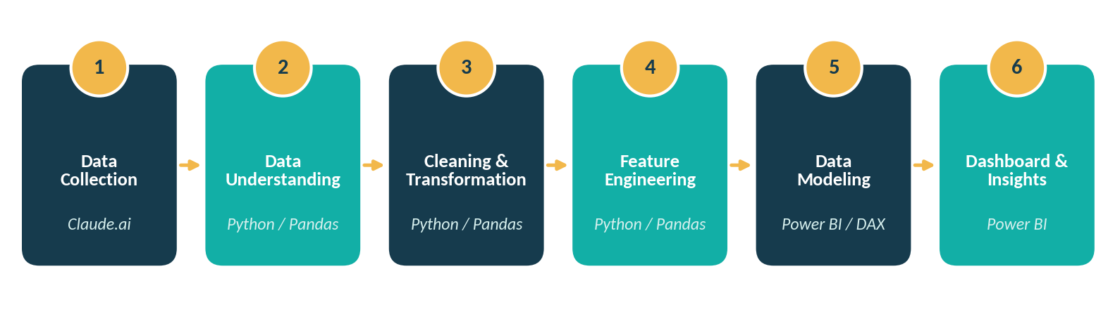
Figure 4.1: End-to-end project workflow

4.2 Phase-wise Summary
Phase | Key activities | Tool | Output
1. Data Collection | Defined the business problem and table design; generated an uncleaned e-commerce supply chain dataset. | Claude.ai | 5 CSV files (4 dimension tables, 1 fact table)
2. Data Understanding | Inspected shape, data types, summary statistics and previews; assessed quality issues. | Python, Pandas | Documented list of data quality issues
3. Cleaning and Transformation | Removed duplicates and invalid records; standardised text, flags, costs and dates; treated missing values. | Python, Pandas | Clean fact table (10,470 rows)
4. Feature Engineering | Created bottleneck, lead-time, fulfilment-gap and delay-percentage features. | Python, Pandas | Analysis-ready workbook (5 sheets, 45-column fact table)
5. Data Modeling | Built the star schema, relationships, date table and DAX measures. | Power BI, DAX | Semantic model with 35 measures
6. Dashboard and Insights | Designed seven interactive pages; interpreted results and recommended actions. | Power BI | Final dashboard and business insights

5. Data Collection from Claude.ai

5.1 Business Context
Real supply chain records are proprietary and rarely available for open analysis. The dataset was therefore generated using Claude.ai for a fictional Indian e-commerce organisation, Nexora Supply Chain Intelligence, modelled on marketplaces such as Amazon, Flipkart, Meesho and Myntra. It uses realistic Indian warehouse cities, regional zones, product categories, logistics carriers and rupee (₹) values.

5.2 Data Generation Requirements
The generation prompt described the business problem and set the following requirements:
- The data must represent an e-commerce organisation such as Amazon, Flipkart, Meesho or Myntra, and must be realistic.
- The design must contain one fact table and more than two dimension tables; Claude was asked to suggest all tables with their attributes and to produce five separate CSV files.
- The fact table must include feature-engineered columns in addition to the transactional fields.
- Only the fact table should be uncleaned; the dimension tables should be clean.
- The fact table must contain more than 10,000 rows, with foreign keys that are correct, repeated and unordered, each drawn from the respective dimension table.

5.3 Generated Tables
File | Table | Type | Rows | Columns | Content
transactions.csv | Transactions | Fact | 10,536 | 44 | Order lines with quantities, costs, dates, delay details, stage durations, weather, traffic and inventory fields
products.csv | Products | Dimension | 20 | 8 | Product name, category, sub-category, priority, standard lead time
supplier.csv | Supplier | Dimension | 15 | 9 | Supplier name, type, location, rating, standard lead time
location.csv | Location | Dimension | 15 | 8 | Warehouse name, type, city, state, region, capacity
transportation.csv | Transportation | Dimension | 15 | 9 | Mode, vehicle, carrier, route, distance, planned transit hours

Notes on the generated data
Dimension tables are clean; the fact table deliberately contains realistic quality problems so the cleaning stage reflects real analytical work.
Delay_Severity, High_Value_Order_Flag and Weather_Risk_Flag were produced by Claude.ai as pre-derived columns within the raw fact table.
After cleaning, the fact table holds 10,470 rows (orders from 5 January 2025 to 17 September 2026) covering 6,078 unique orders. The data is synthetic and does not describe any real company.

6. Data Understanding

6.1 Exploration Approach
Before any changes were made, the raw data was explored in Python to understand its structure, content and quality. All five files were loaded into separate Pandas DataFrames and examined using the techniques below.
Technique | Purpose
shape and head() | Confirm rows and columns in each table and preview the first records.
DataFrame.info() | Review column names, data types and non-null counts.
DataFrame.describe() | Inspect minimum, maximum, mean and spread of numeric columns.
isnull().sum() and duplicated() | Quantify missing values and duplicate records.
unique() on categorical columns | Detect inconsistent spellings, casing and coded values.

6.2 Fact Table Structure
The raw Transactions table has 44 columns that fall into the logical groups below. Each row represents one order line, and an order may contain several lines.
Group | Columns | Description
Keys and identifiers | Transaction_ID, Order_ID, Product_ID, Supplier_ID, Location_ID, Transport_ID | Unique transaction key, order reference and foreign keys to the four dimension tables.
Dates and delivery time | Order_Date, Promised_Delivery_Date, Actual_Delivery_Date, Delivery_Days, Delay_Days | Order, promise and delivery dates, with elapsed delivery time and delay (negative values mean early).
Quantity and value | Quantity_Ordered, Quantity_Delivered, Unit_Cost, Order_Value, Fulfillment_Rate_Pct | Units ordered and delivered, price and order value, and the percentage fulfilled.
Delay outcome | Delay_Status, Delay_Reason, Delay_Severity | Whether the order was delayed, the stated reason, and a severity band.
Stage durations | Procurement_Days, Supplier_Delay_Days, Production_Days, Warehouse_Days, Transportation_Days | Days spent in each stage of the supply chain.
Weather and road conditions | Weather_Condition, Temperature_C, Rainfall_MM, Visibility_KM, Traffic_Level, Traffic_Delay_Minutes, Road_Condition, Road_Closure_Flag, Accident_Flag, Weather_Risk_Flag | External conditions during transport.
Demand and inventory | Demand_Level, Inventory_Level, Stockout_Flag, Warehouse_Capacity_Utilization, High_Value_Order_Flag | Demand pressure, stock position and warehouse load.
Calendar and derived (later dropped) | Order_Weekday, Is_Weekend_Order, Order_Month_Name, Total_Internal_Processing_Days, Cost_Per_Unit_Delivered | Convenience columns with no dashboard value; removed during cleaning.

6.3 Dimension Tables
Table | Profile | Key attributes
Location | 15 warehouses in 15 Indian cities across four regions (North, South, East, West). Types: fulfilment centres, distribution centres and warehouses. | Location_ID, Warehouse_Name, Location_Type, City, State, Region, Warehouse_Capacity, Warehouse_Status
Products | 20 products across 9 categories, including Electronics, Fashion, Home & Kitchen, Beauty & Personal Care and Grocery. Priority levels: 3 High, 9 Medium, 8 Low. | Product_ID, Product_Name, Category, Sub_Category, Unit_of_Measure, Product_Priority, Standard_Lead_Time_Days, Product_Status
Supplier | 15 suppliers (11 manufacturers, 4 distributors) with ratings between 3.4 and 4.5 and an average of 3.96. | Supplier_ID, Supplier_Name, Supplier_Type, Supplier_City, Supplier_State, Supplier_Region, Supplier_Rating, Standard_Lead_Time_Days, Supplier_Status
Transportation | 15 routes operated by 15 carriers (for example Delhivery, Ekart Logistics, Blue Dart Aviation and Indian Railways Freight): 11 road, 2 air and 2 rail. | Transport_ID, Transport_Mode, Vehicle_Type, Carrier_Name, Route_ID, Origin_City, Destination_City, Distance_KM, Planned_Transit_Hours

6.4 Data Quality Assessment
The dimension tables contained no missing values or duplicates. The fact table, however, showed the following issues, each of which would distort KPIs if left untreated.
# | Issue | Evidence in the raw fact table | Impact if untreated
1 | Missing values | Delay_Reason 5,796; Weather_Condition 632; Cost_Per_Unit_Delivered 560; delivery date and duration columns 555 each; weather measures 526 each; Quantity_Delivered and Fulfillment_Rate_Pct 397 each; Supplier_Delay_Days 316; inventory and warehouse utilisation 210 each | Incomplete KPIs and blank chart categories
2 | Duplicate transactions | 36 repeated Transaction_ID values | Double counting of orders and value
3 | Inconsistent text | Mixed upper, lower and title case and stray spaces in status, weather, traffic, road and demand columns; flags written as Yes, Y, True, 1, No, N, False, 0 | One category split into several in visuals
4 | Wrong data type | Unit_Cost stored as text with an “Rs.” prefix and comma separators | Cost cannot be aggregated
5 | Mixed date formats | Five formats: YYYY-MM-DD, DD-MM-YYYY, DD.MM.YYYY, MM/DD/YYYY and DD Mon YYYY | Time-series analysis impossible
6 | Placeholder values | Unit_Cost of -100 and 999999 | Distorted averages and totals
7 | Negative quantities | 30 orders with a negative Quantity_Ordered | Invalid orders
8 | Over-delivery | 40 orders where Quantity_Delivered exceeds Quantity_Ordered | Fulfilment rate above 100%

7. Data Cleaning and Transformation using Python
All preparation was carried out in a Jupyter notebook (SupplyChain_DataCleaning_Python.ipynb) organised into nine documented steps: setup, loading, data understanding, quality assessment, dimension-table cleaning, fact-table cleaning, post-cleaning validation, feature engineering and export. The raw files are never modified; every change happens on in-memory DataFrames and the result is exported separately.

7.1 Setup and Data Loading
Pandas is the only library required for cleaning. The four dimension tables and the fact table were loaded from the raw folder.
import pandas as pd

location_df = pd.read_csv('data/raw/location.csv')
products_df = pd.read_csv('data/raw/products.csv')
supplier_df = pd.read_csv('data/raw/supplier.csv')
transportation_df = pd.read_csv('data/raw/transportation.csv')
transactions_df = pd.read_csv('data/raw/transactions.csv')

7.2 Dimension Table Cleaning
The dimension tables were checked first because the fact table depends on them. All four had zero missing values and zero duplicate rows. As a defensive measure, leading and trailing spaces were stripped from every text column, duplicate rows were dropped (none were found), and each ID column was confirmed to be a unique key using is_unique. The table shapes were unchanged at 15x8, 20x8, 15x9 and 15x9.

7.3 Fact Table: Duplicates and Text Standardisation
Duplicate removal. Each Transaction_ID should appear once, so the first occurrence was kept and the 36 repeats were dropped, reducing the table from 10,536 to 10,500 rows.
Categorical text. Delay_Status, Delay_Reason, Weather_Condition, Traffic_Level, Road_Condition and Demand_Level were trimmed and converted to Title Case. The flag columns Road_Closure_Flag, Accident_Flag and Stockout_Flag, which used eight different spellings of yes and no, were mapped to a clean Yes / No.
transactions_df = transactions_df.drop_duplicates(subset='Transaction_ID', keep='first')

for col in fact_text_cols:
transactions_df[col] = transactions_df[col].str.strip().str.title()

yes_no_map = {'yes':'Yes','y':'Yes','true':'Yes','1':'Yes',
'no':'No','n':'No','false':'No','0':'No'}
for col in ['Road_Closure_Flag', 'Accident_Flag', 'Stockout_Flag']:
transactions_df[col] = transactions_df[col].str.strip().str.lower().map(yes_no_map)

7.4 Fact Table: Numeric Corrections
Unit_Cost. The “Rs.” prefix and commas were removed and the column was converted to a float. The placeholder values -100 and 999999 were treated as missing and replaced with the median unit cost. After cleaning, unit cost ranges from ₹377.16 to ₹31,410.13 with a median of ₹1,367.84.
Quantities. The 30 orders with a negative Quantity_Ordered were removed (10,500 to 10,470 rows). Quantity_Delivered was capped at Quantity_Ordered so that delivered units can never exceed ordered units.
uc = transactions_df['Unit_Cost'].str.replace('Rs.', '', regex=False).str.replace(',', '', regex=False).astype(float)
uc = uc.replace([-100, 999999], float('nan'))
transactions_df['Unit_Cost'] = uc.fillna(uc.median())

transactions_df = transactions_df[transactions_df['Quantity_Ordered'] >= 0]
transactions_df['Quantity_Delivered'] = transactions_df[['Quantity_Delivered', 'Quantity_Ordered']].min(axis=1)

7.5 Date Standardisation
The three date columns mixed five formats. Dates containing a slash follow the Month/Day/Year order, whereas dates written with dashes, dots or a month name follow Day/Month/Year. The two groups were parsed separately and combined, and the result was stored as true datetime values.
def clean_date_column(column):
slash_dates = column.str.contains('/', na=False)
parsed_slash = pd.to_datetime(column, format='%m/%d/%Y', errors='coerce')
parsed_other = pd.to_datetime(column, format='mixed', dayfirst=True, errors='coerce')
return parsed_slash.where(slash_dates, parsed_other)

for c in ['Order_Date', 'Promised_Delivery_Date', 'Actual_Delivery_Date']:
transactions_df[c] = clean_date_column(transactions_df[c])

7.6 Missing Value Treatment
Each column was treated according to why its values were missing, rather than with a single blanket rule.
Column(s) | Missing (raw) | Treatment | Rationale
Delay_Reason | 5,796 | Filled with “No Delay” | Blank when the order was not delayed
Weather_Condition | 632 | Filled with “Unknown” | Weather was not recorded
Quantity_Delivered, Fulfillment_Rate_Pct | 397 each | Filled with 0 | Orders still in transit have delivered nothing yet
Supplier_Delay_Days | 316 | Filled with 0 | No recorded supplier delay means zero days
Temperature_C, Rainfall_MM, Visibility_KM | 526 each | Filled with the median | Typical value avoids skew from outliers
Inventory_Level, Warehouse_Capacity_Utilization | 210 each | Filled with the median | Typical value avoids skew from outliers
Actual_Delivery_Date, Delivery_Days, Delay_Days | 555 each (551 after cleaning) | Left blank on purpose | Belong to 394 in-transit and 157 cancelled orders; inventing values would mislead

7.7 Data Types and Column Removal
Quantity_Delivered and Supplier_Delay_Days no longer contained gaps, so both were converted to integers. Five columns that add no value to the dashboard were then dropped, taking the fact table from 44 to 39 columns.
Dropped column | Reason
Order_Weekday, Is_Weekend_Order, Order_Month_Name | Calendar attributes are supplied by the DateTable in Power BI.
Total_Internal_Processing_Days | Overlaps with the individual stage-duration columns.
Cost_Per_Unit_Delivered | 560 missing values and not used in any dashboard visual.

7.8 Validation and Export
The checks from the assessment stage were re-run on the cleaned data, together with basic business-rule checks. All passed.
Validation check | Result
Duplicate Transaction_ID | 0
Negative Quantity_Ordered | 0
Quantity_Delivered greater than Quantity_Ordered | 0
Actual delivery date earlier than order date | 0
Negative Unit_Cost or Order_Value | 0
Unit_Cost data type | float64 (range ₹377.16 to ₹31,410.13)
Remaining missing values | 551 in the three delivery columns only, by design

Row and column summary
Stage | Rows | Columns
Raw fact table | 10,536 | 44
After removing 36 duplicate transactions | 10,500 | 44
After removing 30 negative-quantity orders | 10,470 | 44
After dropping 5 unnecessary columns | 10,470 | 39
After adding 6 engineered features (Section 8) | 10,470 | 45

Finally, all five tables were written to a single Excel workbook with one worksheet per table, which serves as the data source for Power BI.
with pd.ExcelWriter('data/processed/supply_chain_cleaned.xlsx', engine='openpyxl') as writer:
location_df.to_excel(writer, sheet_name='Location', index=False)
products_df.to_excel(writer, sheet_name='Products', index=False)
supplier_df.to_excel(writer, sheet_name='Supplier', index=False)
transportation_df.to_excel(writer, sheet_name='Transportation', index=False)
transactions_df.to_excel(writer, sheet_name='Transactions', index=False)

8. Feature Engineering using Python
The raw data records what happened; engineered features answer where delays originate and what they cost. Six calculated columns were added to the fact table to support the root-cause and business-impact analysis described in the problem statement.

8.1 Engineered Features
Feature | Logic | Business purpose
Primary_Bottleneck_Stage | The stage (Procurement, Production, Warehouse or Transportation) with the highest number of days for the order | Identifies the root-cause stage of each order
Bottleneck_Days | The number of days taken by that slowest stage | Measures how long the bottleneck lasted
Promised_Lead_Time_Days | Promised_Delivery_Date minus Order_Date | Shows how much time was promised to the customer
Order_Fulfillment_Gap | Quantity_Ordered minus Quantity_Delivered | Counts units short of the order
Undelivered_Order_Value | Order_Fulfillment_Gap multiplied by Unit_Cost | Converts the shortfall into money
Delay_Percentage_of_Promised | Delay_Days divided by Promised_Lead_Time_Days, times 100 | Normalises delay against the promised time so different orders can be compared

8.2 Implementation
stage_cols = ['Procurement_Days', 'Production_Days', 'Warehouse_Days', 'Transportation_Days']

df['Primary_Bottleneck_Stage'] = df[stage_cols].idxmax(axis=1)
df['Bottleneck_Days'] = df[stage_cols].max(axis=1)
df['Promised_Lead_Time_Days'] = (df['Promised_Delivery_Date'] - df['Order_Date']).dt.days
df['Order_Fulfillment_Gap'] = df['Quantity_Ordered'] - df['Quantity_Delivered']
df['Undelivered_Order_Value'] = df['Order_Fulfillment_Gap'] * df['Unit_Cost']
df['Delay_Percentage_of_Promised'] = df['Delay_Days'] / df['Promised_Lead_Time_Days'] * 100

8.3 Results
The bottleneck feature immediately shows that procurement is the slowest stage for the large majority of transaction lines.
Primary bottleneck stage | Transaction lines | Share
Procurement | 7,364 | 70.3%
Transportation | 1,569 | 15.0%
Production | 1,391 | 13.3%
Warehouse | 146 | 1.4%
Total | 10,470 | 100%

- The promised lead time averages 12.9 days and ranges from 4 to 25 days.
- 944 transaction lines were short-delivered, and the undelivered order value totals about ₹4.57 crore (₹45.7 million), roughly 4.3% of total order value of ₹107.1 crore.
- Delay_Percentage_of_Promised is blank for in-transit and cancelled lines, which have no delay value to normalise.
- Alongside these six features, the raw data already included Delay_Severity, High_Value_Order_Flag and Weather_Risk_Flag, so the final fact table carries 45 analysis-ready columns.

9. Data Modeling

9.1 Star Schema
The cleaned workbook was loaded into Power BI and modelled as a star schema: a central Transactions fact table surrounded by dimension tables for products, suppliers, locations and transportation, plus a DateTable for time intelligence. This design keeps the model simple, makes filters flow predictably from dimensions to facts, and keeps DAX measures fast and easy to read.
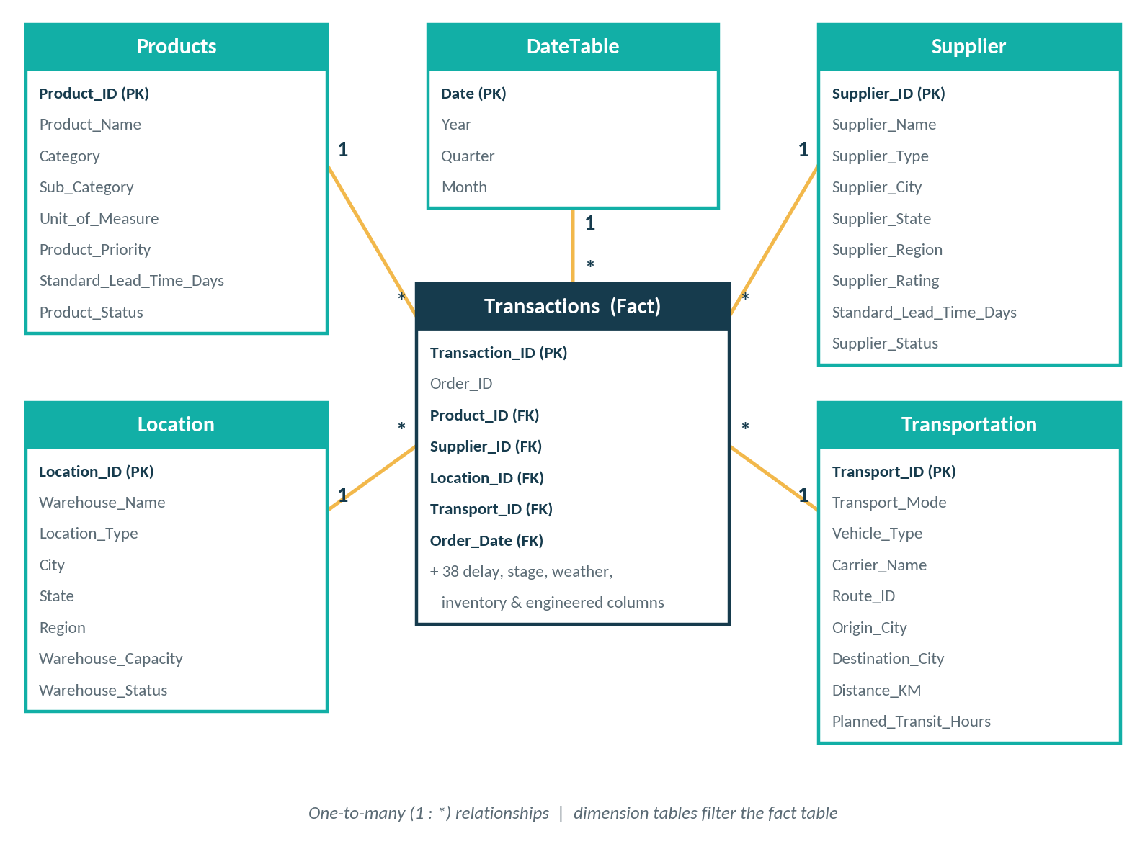
Figure 9.1: Star schema data model
Table | Type | Primary key | Role in the model
Transactions | Fact | Transaction_ID | Order-line events and all measurable fields (10,470 rows)
Products | Dimension | Product_ID | Category and product analysis (20 rows)
Supplier | Dimension | Supplier_ID | Supplier performance and rating (15 rows)
Location | Dimension | Location_ID | Warehouse and regional analysis (15 rows)
Transportation | Dimension | Transport_ID | Mode, carrier and route attributes (15 rows)
DateTable | Dimension | Date | Year, quarter and month for trends and slicers

9.2 Relationships
Dimension (one side) | Fact table (many side) | Cardinality | Filter direction
Products[Product_ID] | Transactions[Product_ID] | One-to-many | Dimension to fact
Supplier[Supplier_ID] | Transactions[Supplier_ID] | One-to-many | Dimension to fact
Location[Location_ID] | Transactions[Location_ID] | One-to-many | Dimension to fact
Transportation[Transport_ID] | Transactions[Transport_ID] | One-to-many | Dimension to fact
DateTable[Date] | Transactions[Order_Date] | One-to-many | Dimension to fact

Because the fact table holds only keys and measurable fields, slicers placed on Region, Category, Supplier or Year filter every visual on the page consistently.

9.3 DateTable
A dedicated DateTable provides the Year, Quarter and Month fields used by the Year slicer, the quarterly delay-rate trend and every monthly trend chart. It also hosts the Last Refresh measure that displays the report’s last-refreshed timestamp in the page header.

9.4 DAX Measures
Business logic is centralised in 35 DAX measures, so every visual uses the same definitions. Total Orders counts unique Order_ID values, whereas Total Transactions counts order lines, which is why the dashboard reports 6.1K orders against 10,470 transaction lines.
Category | Measures | Purpose
Volume and delay KPIs (10) | Total Orders, Total Transactions, Delayed Orders, Delay Rate, Average Delay Days, Total Delay Days, Maximum Delay Days, Severe Delays, Delay % of Promised Lead Time, Total Order Value | Headline delivery performance and delay severity
Bottleneck (4) | Total Bottleneck Days, Average Bottleneck Days, Bottleneck Orders, Critical Bottleneck Orders | Time lost to the slowest stage and critical cases
Supplier and procurement (4) | Supplier Delay Rate, Average Supplier Delay Days, Average Procurement Days, Average Supplier Rating | Supplier reliability and procurement speed
Logistics and risk (5) | Average Transportation Days, Average Traffic Delay Mins, Weather Risk Orders, Road Closure Orders, Accident Affected Orders | Transport performance and external disruptions
Inventory and fulfilment (5) | Total Quantity Ordered, Total Quantity Delivered, Fulfillment Rate, Stockout Orders, Average Warehouse Utilization | Stock availability and order completion
Display and helper (7) | Order ID, Delay Status, Weather Condition Explanation, Bottleneck Stage Color, Delay Reason Color, Severity Color, Last Refresh | Dynamic labels, conditional colours and the refresh timestamp

10. Dashboard Development in Power BI

10.1 Design Approach
The dashboard, branded Nexora Supply Chain Intelligence, is organised as a guided journey from the big picture to individual orders. The Executive Overview answers “how are we doing?”, the diagnostic pages answer “where and why?”, and Order Details answers “which orders?”.
- Consistent layout: every page has a title, a row of KPI cards, a filter strip and two to four supporting visuals.
- Colour with meaning: navy and teal form the base theme, while an amber accent highlights the leading contributor in a chart, such as the top delay reason or the worst category.
- Conditional formatting: colour measures (bottleneck stage, delay reason and severity) and heat-map shading in tables draw the eye to problem areas.
- Readable visuals: line charts for trends, columns and bars for comparisons, matrices for two-way breakdowns and a scatter plot for relationships.

10.2 Navigation and Interactivity
A left-hand navigation panel links the seven pages. Every page also provides a Reset Filters button, a back arrow and a Last Refreshed timestamp. Year and Region slicers are present on every page, together with page-specific filters.
Page | Slicers available
Executive Overview | Year, Region, Category, Delay Status
Delay Analysis | Year, Region, Category, Delay Reason, Supplier
Bottleneck Analysis | Year, Region, Category, Supplier
Supplier & Procurement Analysis | Year, Region, Supplier, Category
Logistics & Risk Analysis | Year, Region, Traffic Level, Category
Inventory & Fulfillment Analysis | Year, Region, Category, Demand Level
Order Details | Year, Region, Supplier, Category, Bottleneck Stage, Delay Severity, Delay Status

10.3 Executive Overview
The landing page gives leadership a one-glance summary of delivery health, the most common causes of delay and the stage where time is lost.
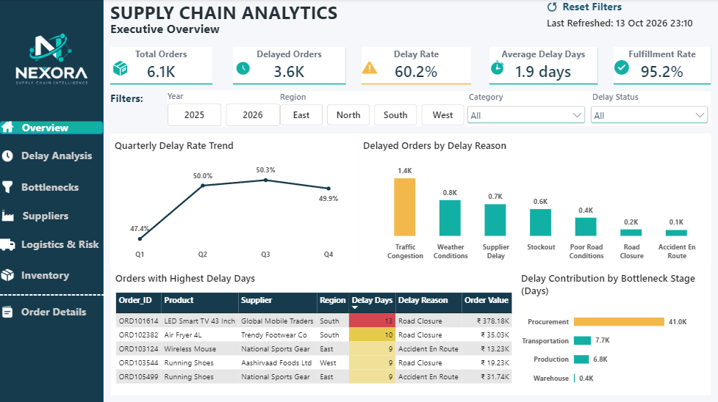
Figure 10.1: Executive Overview page
Component | Visual type | What it shows
KPI cards | Cards | Total Orders, Delayed Orders, Delay Rate, Average Delay Days and Fulfillment Rate
Quarterly Delay Rate Trend | Line chart | Delay rate by quarter
Delayed Orders by Delay Reason | Column chart | Frequency of each recorded delay reason, with the top reason highlighted
Orders with Highest Delay Days | Table | Worst individual orders with delay days colour-coded from yellow to red
Delay Contribution by Bottleneck Stage | Bar chart | Total bottleneck days by supply chain stage

10.4 Delay Analysis
This page examines how often orders are delayed, how severe the delays are and how they vary over time, by region and by product category.
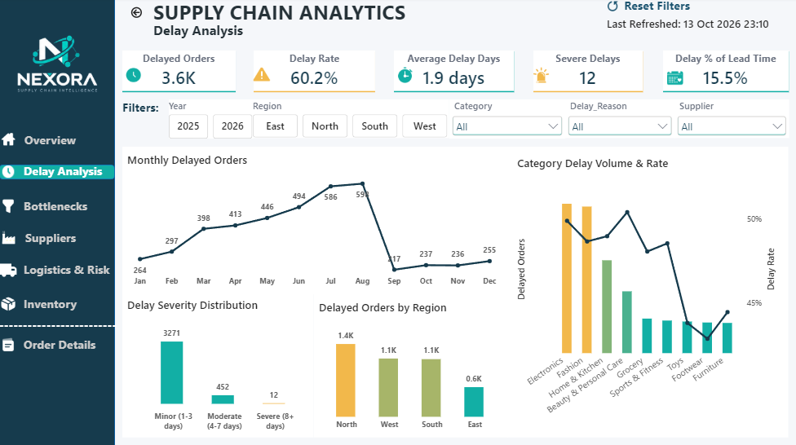
Figure 10.2: Delay Analysis page
Component | Visual type | What it shows
KPI cards | Cards | Delayed Orders, Delay Rate, Average Delay Days, Severe Delays and Delay % of Lead Time
Monthly Delayed Orders | Line chart | Month-by-month delayed order counts
Delay Severity Distribution | Column chart | Minor (1 to 3 days), Moderate (4 to 7 days) and Severe (8+ days) delays
Delayed Orders by Region | Column chart | Delay volume for North, West, South and East
Category Delay Volume & Rate | Combo chart | Delayed orders (columns) and delay rate (line) for each category

10.5 Bottleneck Analysis
The bottleneck page identifies which stage of the supply chain consumes the most time and where, using the engineered bottleneck features.
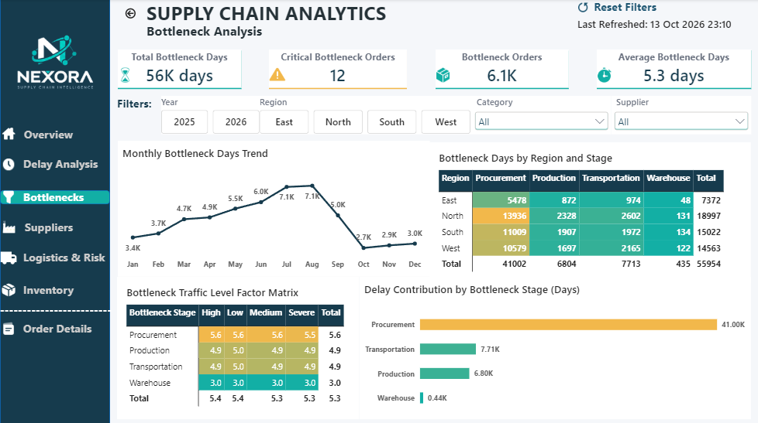
Figure 10.3: Bottleneck Analysis page
Component | Visual type | What it shows
KPI cards | Cards | Total Bottleneck Days, Critical Bottleneck Orders, Bottleneck Orders and Average Bottleneck Days
Monthly Bottleneck Days Trend | Line chart | Bottleneck days by month
Bottleneck Days by Region and Stage | Matrix with heat map | Days lost in each stage for every region
Bottleneck Traffic Level Factor Matrix | Matrix with heat map | Average bottleneck days for each stage across traffic levels
Delay Contribution by Bottleneck Stage | Bar chart | Share of total bottleneck days by stage

10.6 Supplier & Procurement Analysis
This page evaluates supplier reliability and procurement speed, since procurement is the largest source of lost time.
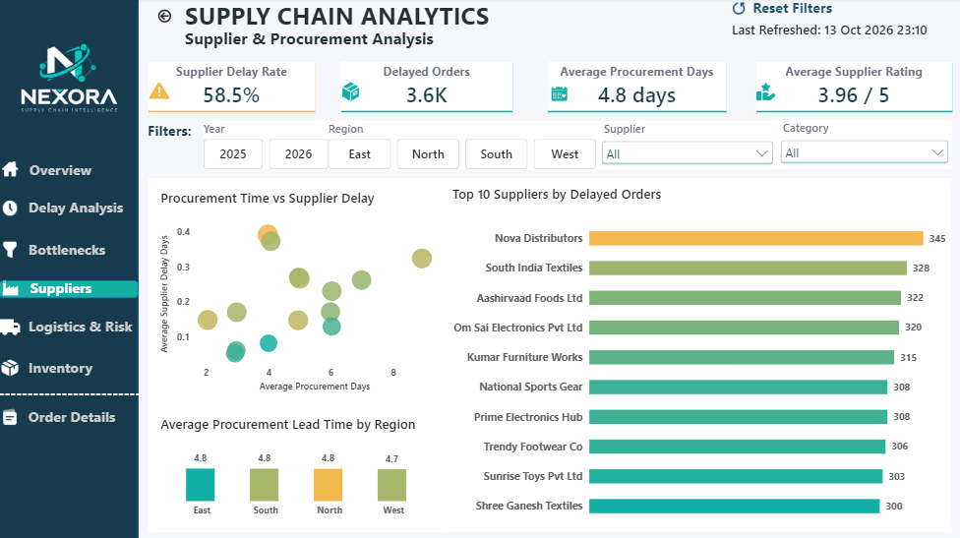
Figure 10.4: Supplier & Procurement Analysis page
Component | Visual type | What it shows
KPI cards | Cards | Supplier Delay Rate, Delayed Orders, Average Procurement Days and Average Supplier Rating
Procurement Time vs Supplier Delay | Scatter plot | Relationship between average procurement days and supplier delay days
Average Procurement Lead Time by Region | Column chart | Procurement days compared across regions
Top 10 Suppliers by Delayed Orders | Bar chart | Suppliers ranked by delayed order count

10.7 Logistics & Risk Analysis
This page analyses transportation performance and the external risks that affect delivery: traffic, weather, road condition, closures and accidents.
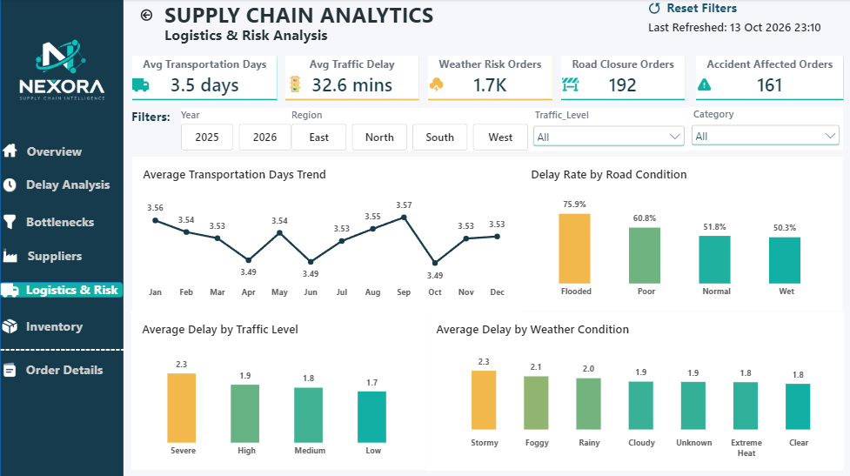
Figure 10.5: Logistics & Risk Analysis page
Component | Visual type | What it shows
KPI cards | Cards | Average Transportation Days, Average Traffic Delay, Weather Risk Orders, Road Closure Orders and Accident Affected Orders
Average Transportation Days Trend | Line chart | Monthly transportation time
Delay Rate by Road Condition | Column chart | Delay rate for flooded, poor, normal and wet roads
Average Delay by Traffic Level | Column chart | Average delay for severe, high, medium and low traffic
Average Delay by Weather Condition | Column chart | Average delay under each weather condition

10.8 Inventory & Fulfillment Analysis
This page links stock availability to delivery performance and tracks how completely orders are fulfilled.
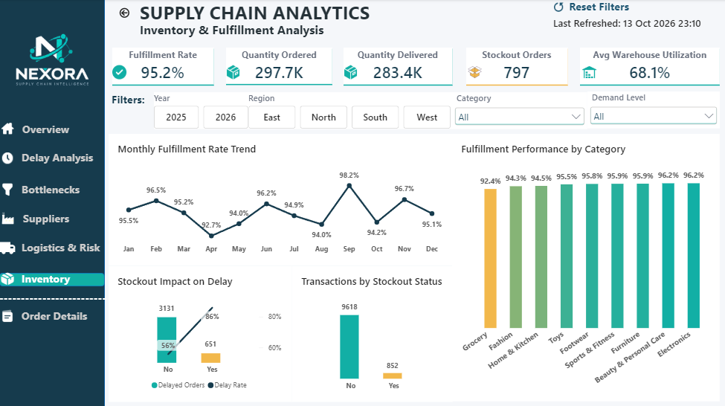
Figure 10.6: Inventory & Fulfillment Analysis page
Component | Visual type | What it shows
KPI cards | Cards | Fulfillment Rate, Quantity Ordered, Quantity Delivered, Stockout Orders and Average Warehouse Utilization
Monthly Fulfillment Rate Trend | Line chart | Fulfilment rate by month
Fulfillment Performance by Category | Column chart | Fulfilment rate for each product category
Stockout Impact on Delay | Combo chart | Delayed orders and delay rate with and without a stockout
Transactions by Stockout Status | Column chart | Number of transactions with and without a stockout

10.9 Order Details
The final page supports drill-down to individual orders and their transaction lines. In the example shown, order ORD103544 has two transaction lines from different suppliers and with different delay outcomes.
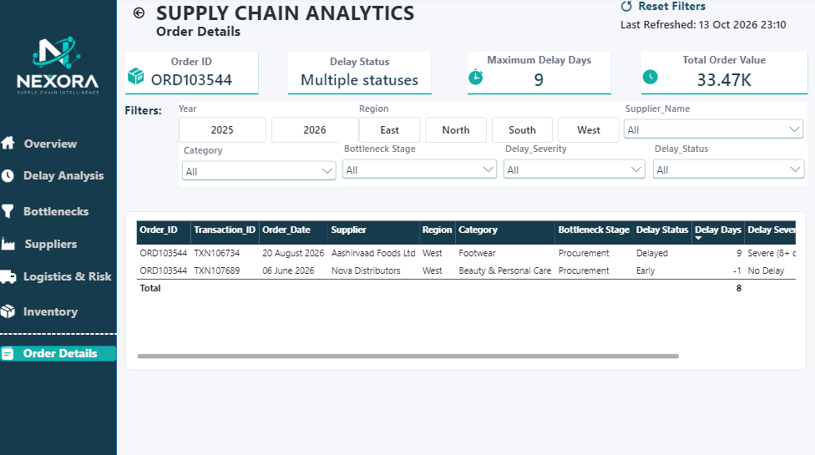
Figure 10.7: Order Details page
Component | Visual type | What it shows
KPI cards | Cards | Order ID, Delay Status, Maximum Delay Days and Total Order Value for the selection
Order detail table | Table | Order, transaction, date, supplier, region, category, bottleneck stage, delay status, delay days and severity
Extended filters | Slicers | Bottleneck Stage, Delay Severity and Delay Status in addition to the standard filters

11. Key Business Insights
The findings below are read directly from the dashboard. Percentages and counts reflect the full 2025 to 2026 period unless stated otherwise.

11.1 Overall Delivery Performance
- Delays are the norm. Of roughly 6.1K orders, 3.6K were delayed, giving a delay rate of 60.2%. Delayed orders ran late by 1.9 days on average, equal to 15.5% of the promised lead time.
- Delays are frequent but mostly short. 3,271 delayed orders were minor (1 to 3 days), 452 were moderate (4 to 7 days) and only 12 were severe (8+ days). The challenge is the consistency of delays rather than extreme cases.
- Quantity fulfilment is healthy. 95.2% of ordered units were delivered (283.4K of 297.7K), so the gap lies mainly in timeliness.

11.2 Where Delays Originate
- Procurement is the dominant bottleneck. It accounts for 41.0K of 56.0K total bottleneck days (73%), ahead of transportation (7.7K, 14%), production (6.8K, 12%) and warehouse (0.4K, under 1%).
- Orders whose slowest stage was procurement lost 5.6 days on average, compared with 4.9 days for production and transportation and 3.0 days for the warehouse.
- North is the most affected region with 19.0K bottleneck days (34% of the total), of which 13.9K are procurement. East is the lowest at 7.4K days.
- Average bottleneck days barely change across traffic levels (5.3 to 5.4), which indicates the bottleneck is driven by internal process time rather than road traffic.
- Two complementary views. Recorded delay reasons place Traffic Congestion first (1.4K), followed by Weather Conditions (0.8K), Supplier Delay (0.7K) and Stockout (0.6K). Time spent by stage places procurement first. External disruptions trigger visible delays, while long procurement time consumes the buffer that would otherwise absorb them.

11.3 Supplier and Procurement Performance
- The supplier delay rate is 58.5%, with average procurement time of 4.8 days and an average supplier rating of 3.96 out of 5.
- The ten suppliers with the most delayed orders range narrowly from 300 to 345 orders, led by Nova Distributors (345), South India Textiles (328) and Aashirvaad Foods Ltd (322). Such a tight spread suggests a systemic issue rather than a few poor performers.
- Average procurement lead time is almost identical across regions (4.7 to 4.8 days), pointing to a common process rather than a regional problem.

11.4 Logistics and External Risk
- Road condition has the strongest effect. The delay rate is 75.9% on flooded roads and 60.8% on poor roads, versus 51.8% on normal roads, roughly 24 percentage points higher for flooded roads.
- Stormy weather produces the longest average delay (2.3 days), followed by foggy (2.1) and rainy (2.0), against 1.8 days in clear conditions. Severe traffic adds a similar premium (2.3 days against 1.7 in low traffic).
- Average transportation time is stable at about 3.5 days throughout the year, and average traffic delay is 32.6 minutes.
- External risk events are limited in volume: 1.7K weather-risk orders, 192 road-closure orders and 161 accident-affected orders.

11.5 Inventory and Fulfillment
- Stockouts sharply increase the chance of delay. The delay rate is 86% for orders with a stockout against 56% without, a difference of about 30 percentage points. Stockouts affected 797 orders (852 of 10,470 transaction lines, or 8%).
- Category fulfilment is tightly grouped between 94% and 96%, with Grocery the lowest at 92.4%. Monthly fulfilment ranges from 92.7% (April) to 98.2% (September).
- Average warehouse utilisation is 68.1%, leaving headroom in capacity, so stockouts are more likely to be a replenishment issue than a space issue.

11.6 Categories and Time Patterns
- Electronics and Fashion generate the largest volume of delayed orders, while delay rates across categories sit in a fairly narrow band, so delay is a systemic issue rather than a category-specific one.
- The quarterly delay rate rises from 47.4% in Q1 to about 50% in Q2 and stays near that level through Q4.

Data coverage note
The monthly charts combine 2025 and 2026, and the data ends on 17 September 2026. Months from October to December therefore reflect 2025 only. The drop in delayed orders after August is a result of data coverage and should not be read as an improvement. Use the Year slicer for like-for-like comparisons.

11.7 Recommendations
- Shorten procurement time first. With 73% of bottleneck days, procurement offers the largest gain. Introduce supplier lead-time agreements, earlier purchase-order triggers and an escalation path for slow orders, starting with the North region.
- Reduce stockouts through better replenishment. Stockouts raise the delay rate by about 30 points. Use demand-based reorder points and safety stock, with early attention to Grocery, which has the lowest fulfilment.
- Plan for weather and road risk. Add buffer time in the promised date for flood-prone routes, and use alternative routing or carriers during stormy, foggy and rainy conditions.
- Manage congestion proactively. As the most frequent recorded delay reason, congestion can be reduced with off-peak dispatch and delivery time windows.
- Run a supplier improvement programme. Because delays are spread evenly across suppliers, apply common service-level targets and scorecards to all of them rather than only the lowest rated.
- Set realistic promise dates. Delays average 15.5% of lead time, so calibrating promised dates by region and category would reduce missed commitments without changing operations.
- Monitor severe and critical cases. Track the 12 severe delays and the critical bottleneck orders through the Order Details page and escalate them early.

12. Tools Used
Tool | Category | Purpose in this project
Claude.ai | AI assistant | Suggested the table design and generated the synthetic e-commerce supply chain dataset as five CSV files.
Python | Programming language | Data understanding, cleaning, transformation and feature engineering.
Pandas | Python library | Loading CSV files, handling missing values, standardising text and dates, and creating engineered columns.
openpyxl | Python library | Excel writer engine used to export the cleaned tables to one workbook.
Jupyter Notebook | Development environment | Documented, step-by-step cleaning and feature-engineering workflow with outputs.
Microsoft Excel | Spreadsheet | Stores the cleaned data (five worksheets) used as the Power BI data source.
Power BI Desktop | Business intelligence | Data modelling, relationships and the seven-page interactive dashboard.
DAX | Query language | Thirty-five measures for KPIs, bottleneck metrics, conditional colours and dynamic labels.
Microsoft Word | Documentation | Preparation of this project report.

13. System Configuration
The project was developed and tested on the following system.
Component | Configuration
Operating System | Windows 11
Processor | AMD Ryzen 3 7320U with Radeon Graphics
Processor Speed | 2.40 GHz
RAM | 8 GB
Storage | 238 GB

14. Conclusion
This project delivered a complete analytics solution for supply chain delay analysis, from data generation through to an interactive Power BI dashboard. A realistic e-commerce dataset of more than ten thousand transactions was generated, its quality problems were systematically diagnosed and corrected in Python, six features were engineered to expose root causes, and the result was modelled as a star schema with 35 reusable DAX measures.
The resulting seven-page dashboard turns fragmented operational data into clear, actionable insight. It shows that 60.2% of orders are delayed, that procurement accounts for about 73% of all bottleneck days, that stockouts raise the delay rate by roughly 30 percentage points, and that flooded roads push the delay rate to 75.9%. Together these findings direct attention to the places where corrective action will have the greatest effect.
Beyond the business findings, the project demonstrates an end-to-end analytical workflow: problem definition, data preparation, feature engineering, modelling, visualisation and recommendation. The same approach can be applied to live organisational data to move supply chain management from reactive reporting to proactive, evidence-based decision-making.

15. Future Scope
The solution can be extended in several directions:
- Predictive delay modelling: train a classification model on supplier, weather, traffic, stage and inventory features to predict which orders are likely to be delayed before they ship.
- Real-time data integration: connect to live order, warehouse and transport systems with scheduled or incremental refresh, and add alerts when delay thresholds are crossed.
- Financial impact analysis: surface the already engineered Order_Fulfillment_Gap and Undelivered_Order_Value (about ₹4.57 crore in this dataset) on a dedicated cost-of-delay page.
- Supplier risk scoring: combine rating, delay rate and procurement time into a composite score to support supplier selection and negotiation.
- Route and carrier optimisation: use the Transportation dimension to compare carriers, modes and distances against planned transit hours.
- What-if scenarios: let users simulate the effect of reducing procurement days or stockouts on the overall delay rate.
- Advanced analytics visuals: add Key Influencers and Decomposition Tree visuals to automate root-cause discovery.
- Role-based and mobile access: apply row-level security so regional managers see only their region, and add mobile-optimised layouts.

